Database

What is a Database?
# Source: AI Source: Provided by: [Data Path: Persons Table -> ID Column: 1, Name_En Column: Motasem Essam] -> From: [Chatgpt (GPT‑5 Mini)] on [12/10/2025]
A database is an organized collection of data that is stored electronically and can be easily accessed, managed, and updated by a computer system.
Databases allow users and programs to store large amounts of information and retrieve it efficiently.

Simple Definition
# Source: AI Source: Provided by: [Data Path: Persons Table -> ID Column: 1, Name_En Column: Motasem Essam] -> From: [Chatgpt (GPT‑5 Mini)] on [12/10/2025]
A database is a system used to store, organize, and manage data so it can be easily retrieved and modified.

Example of a Database
# Source: AI Source: Provided by: [Data Path: Persons Table -> ID Column: 1, Name_En Column: Motasem Essam] -> From: [Chatgpt (GPT‑5 Mini)] on [12/10/2025]
A student database might look like this:
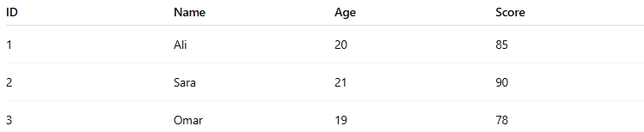
ID | Name | Age | Score
1 | Ali | 20 | 85
2 | Sara | 21 | 90
3 | Omar | 19 | 78
Here:
- Each row represents a student record.
- Each column represents a type of information (attribute).

Components of a Database

1. Tables
# Source: AI Source: Provided by: [Data Path: Persons Table -> ID Column: 1, Name_En Column: Motasem Essam] -> From: [Chatgpt (GPT‑5 Mini)] on [12/10/2025]
Data in a database is usually stored in tables.
Example table:
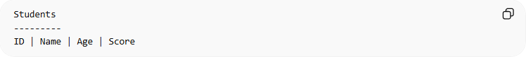
Students
---------
ID | Name | Age | Score

2. Records (Rows)
# Source: AI Source: Provided by: [Data Path: Persons Table -> ID Column: 1, Name_En Column: Motasem Essam] -> From: [Chatgpt (GPT‑5 Mini)] on [12/10/2025]
A record represents one complete set of information.
Example:
1 | Ali | 20 | 85

3. Fields (Columns)
# Source: AI Source: Provided by: [Data Path: Persons Table -> ID Column: 1, Name_En Column: Motasem Essam] -> From: [Chatgpt (GPT‑5 Mini)] on [12/10/2025]
A field represents a specific attribute of the data.
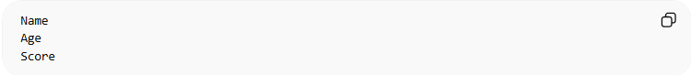
Example:
Name
Age
Score

4. Database Management System (DBMS)
# Source: AI Source: Provided by: [Data Path: Persons Table -> ID Column: 1, Name_En Column: Motasem Essam] -> From: [Chatgpt (GPT‑5 Mini)] on [12/10/2025]
A DBMS is software used to create, manage, and interact with databases.
Examples of DBMS:
- MySQL
- Oracle Database
- Microsoft SQL Server
- PostgreSQL
These systems allow users to:
- Insert data
- Update data
- Delete data
- Retrieve data using queries

Why Databases Are Important
# Source: AI Source: Provided by: [Data Path: Persons Table -> ID Column: 1, Name_En Column: Motasem Essam] -> From: [Chatgpt (GPT‑5 Mini)] on [12/10/2025]
Databases help organizations:
- Store large amounts of data
- Retrieve information quickly
- Maintain data accuracy
- Support applications like websites, banking systems, and business software
Example uses:
- Banking systems
- Hospital records
- Online shopping websites
- University student systems

Simple Example in Real Life
# Source: AI Source: Provided by: [Data Path: Persons Table -> ID Column: 1, Name_En Column: Motasem Essam] -> From: [Chatgpt (GPT‑5 Mini)] on [12/10/2025]
A library system may use a database to store:
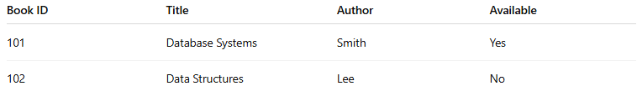
Book ID | Title | Author | Available
101 | Database Systems | Smith | Yes
102 | Data Structures | Lee | No
This allows the system to quickly check whether a book is available.

Database vs Dataset

What is a Dataset?
# Source: AI Source: Provided by: [Data Path: Persons Table -> ID Column: 1, Name_En Column: Motasem Essam] -> From: [Chatgpt (GPT‑5 Mini)] on [12/10/2025]
A dataset is a collection of related data, usually organized in tables, files, or records for analysis or processing.
Examples of datasets:
- A CSV file containing student grades
- A table of sales data for one year
- A spreadsheet with customer information
A dataset is often smaller and simpler than a database.

What is a Database?
# Source: AI Source: Provided by: [Data Path: Persons Table -> ID Column: 1, Name_En Column: Motasem Essam] -> From: [Chatgpt (GPT‑5 Mini)] on [12/10/2025]
A database is a structured system designed to store, manage, and retrieve large amounts of data efficiently.
It usually contains multiple datasets (tables) and is managed by a Database Management System (DBMS).
Examples:
- MySQL database
- PostgreSQL database
- Oracle database

Relationship Between Dataset and Database
# Source: AI Source: Provided by: [Data Path: Persons Table -> ID Column: 1, Name_En Column: Motasem Essam] -> From: [Chatgpt (GPT‑5 Mini)] on [12/10/2025]
You can think of it like this:
Database → contains multiple datasets (tables)
Example:
Database: University Database
Datasets (tables) inside it:
- Students dataset
- Courses dataset
- Grades dataset
- Professors dataset

Comparison
# Source: AI Source: Provided by: [Data Path: Persons Table -> ID Column: 1, Name_En Column: Motasem Essam] -> From: [Chatgpt (GPT‑5 Mini)] on [12/10/2025]
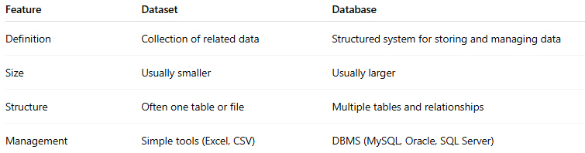
Feature | Dataset | Database
Definition | Collection of related data | Structured system for storing and managing data
Size | Usually smaller | Usually larger
Structure | Often one table or file | Multiple tables and relationships
Management | Simple tools (Excel, CSV) | DBMS (MySQL, Oracle, SQL Server)

✅ Conclusion:
# Source: AI Source: Provided by: [Data Path: Persons Table -> ID Column: 1, Name_En Column: Motasem Essam] -> From: [Chatgpt (GPT‑5 Mini)] on [12/10/2025]
- A dataset is a collection of data.
- A database is a system that stores and manages many datasets.

✅ Summary:
# Source: AI Source: Provided by: [Data Path: Persons Table -> ID Column: 1, Name_En Column: Motasem Essam] -> From: [Chatgpt (GPT‑5 Mini)] on [12/10/2025]
A database is an organized electronic system used to store, manage, and retrieve data efficiently, usually using tables with rows and columns.

